Sunday, June 1, 2014
2014 ASFPM Golf Outing—Chambers Bay Golf Course, Tacoma, WA
Site of the 2015 United States Open

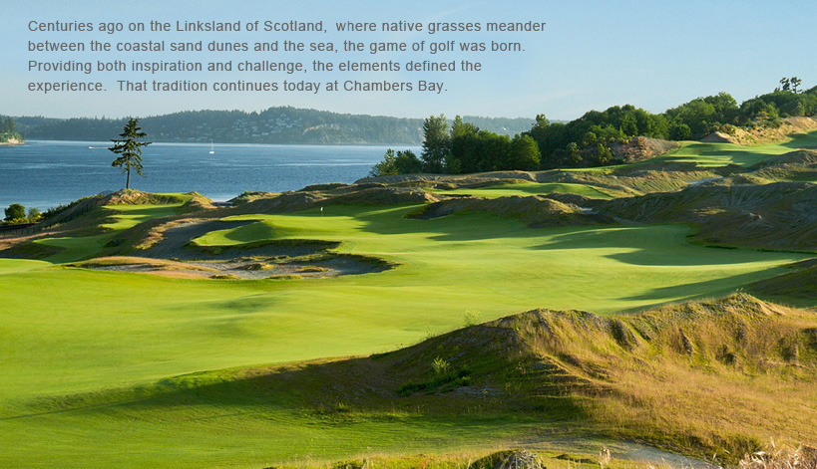
The above photo taken from the Chambers Bay Website

Wow ASFPM golfers! This year we’ll be playing at a world-class venue, Chambers Bay Golf Course in Tacoma, Washington, site of the 2015 U.S. Open Championship. You will be able to experience the same course on which elite PGA players will be competing next year. Many of us will never have the opportunity to play such a golf course again. Check out the Chambers Bay website at www.ChambersBaygolf.com. This links-style, Robert Trent Jones II design, is set into a hillside with every hole overlooking the majestic marine waters of the Puget Sound.

And, the format for the outing is going to be different from previous years. There will not be a tournament as such, although there may be some group challenges and trash-talking going on in the hotel…. We’ll be playing just straight up golf in foursomes. Plan on just enjoying the day, your friends, the golf course and the unbelievable scenery afforded by the beautiful Puget Sound. Some things to know:

- The green fee is $135. Yes, this is a bit pricey, but we’re talking a U.S. Open venue!

- This is a Walking Only golf course. No power carts are allowed. Complimentary pull carts are available.

- After the round the Chambers Bay Grill will be a great place for you to purchase a beverage and sandwich and affords an opportunity to discuss the highlights of your day.

We’ve managed to reserve times for 40 golfers (10 foursomes). Interest is high! Reserve your spot right now before the field is filled by sending an email to Tony Melone at tonyasfpm@gmail.com. You may register individually or as a group. We will follow-up with you to arrange for payment and provide more details and directions for getting to the course.

